These are low and free apps that are available and I could use them in my classroom.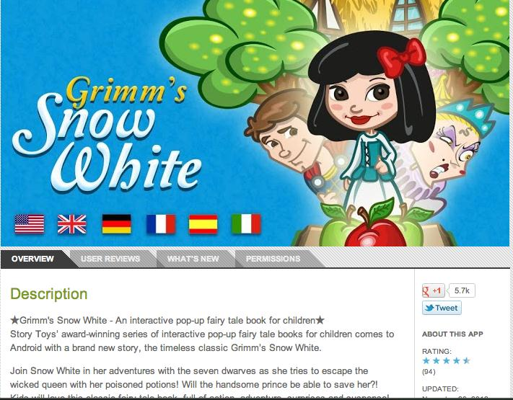
The Snow White is an interactive story that will keep young children interest, make reading and listening to a story much more exciting which will helps in developing their own learning.
Other emerging tech- Free Interactive White Boards use for collaboration.
1. Twiddla.com
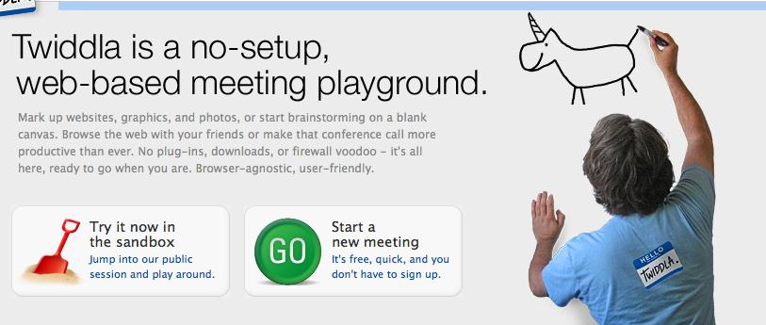
2.Vyew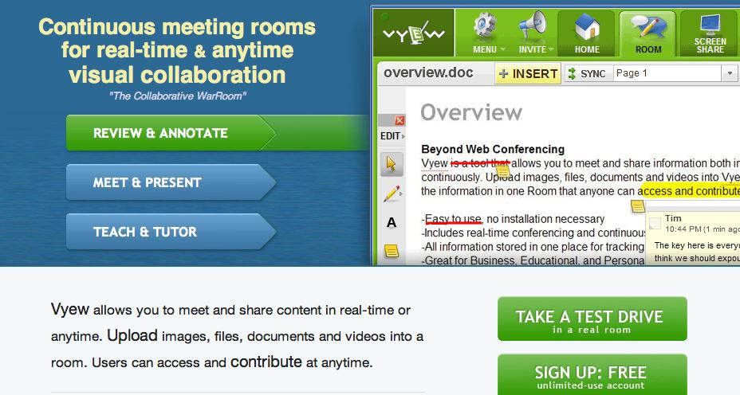
This is a great learning tool for matching animals, numbers and much much more! It has an assessment tool that tracks individual progress
Below is an embedded video Former NBA player Jerry Luca has great ideals emerging technologies for revolutionizing how children learn.
<iframe width="420" height="315" src="http://www.youtube.com/embed/j3sz72P0FC4" frameborder="0" allowfullscreen></iframe
Safe Social Networking for children (approx ages 8-14)
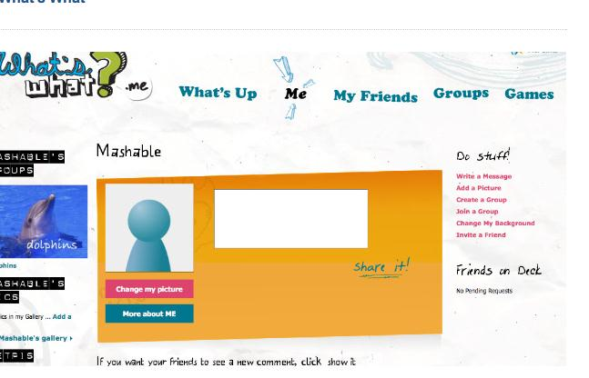
What’s What seems to be the most secure, Parents have to use their credit card information and send picture of the children. The sight is check and can recognize is someone has posted invalid information. Children have to network with same age group.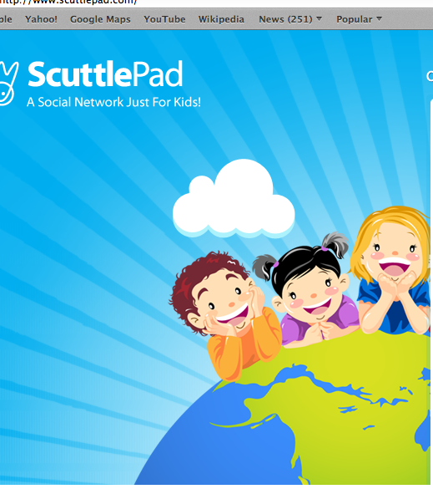
Scuttle Pad is another kid safe social network less secure than What’s What. www.scuttlepad.com. Kids can meet and talk to friends across the world.

